IPAK5 Notes and Details

Information

Data Universal Numbering System (DUNS)
Company | NEWTON RESEARCH & DEVELOPMENT CENTRE SDN. BHD.
DUNS Number | 66-073-3656

AWS Credential

Personal Account
Link | https://ap-southeast-2.signin.aws.amazon.com/oauth?response_type=code&client_id=arn%3Aaws%3Asignin%3A%3A%3Aconsole%2Fcanvas&redirect_uri=https%3A%2F%2Fap-southeast-2.console.aws.amazon.com%2Fconsole%2Fhome%3Fca-oauth-flow-id%3D93c0%26hashArgs%3D%2523%26isauthcode%3Dtrue%26region%3Dap-southeast-2%26state%3DhashArgsFromTB_ap-southeast-2_560e36a9d0c64664&forceMobileLayout=0&forceMobileApp=0&code_challenge=upBo4fn83YpAJVTOlv3_gGvy_s_Lf4Rm9VRgYb-PZqU&code_challenge_method=SHA-256
ID | 976264164493
Username | alif.mis@thongguan.com
Password | Thong7788@

Admin Account
Link | https://976264164493.signin.aws.amazon.com/console
Username | mis@thongguan.com
Password | Newton888@TG

Public IP Address (For external access)
Public IPv4 | 3.219.54.252
Public DNS | ec2-3-219-54-252.compute-1.amazonaws.com

Private IP Address (For internal/VPC access):
Public IPv4 | 172.31.38.199
Public DNS | ip-172-31-38-199.ec2.internal

Database (MySQL Workbench)
Connection Name | ipak5/EC2-MySQ
Connection Method | Standard (TCP/IP)
Hostname | 3.219.54.252
Port | 3306
Username | root
Password | ipack5@123456#

PWA Environment

Test
Domain | ai-thongguan.com
Web URL | https://ipak5.ai-thongguan.com
Web Original URL | http://192.168.1.146:94/
API URL | https://api.ai-thongguan.com/swagger/index.html?urls.primaryName=IPAK5
API Original URL | http://192.168.1.146:84/swagger/index.html?urls.primaryName=IPAK5

Live
Domain | Ipak5.com
Web URL | https://ipak5.com
Web Original URL | http://3.219.54.252:5002
API URL | https://api.ipak5.com/swagger/index.html
API Original URL | http://3.219.54.252:5001/swagger/index.html

Developer Credential

Huawei Credential
Link | https://developer.huawei.com/consumer/en/verified/enrollment
Username | ipak5.newton@gmail.com
Password | #20*May*2026#_X@xL%

Android Credential
Link | https://play.google.com/console/u/0/developers
Username | mistech51@thongguan.com / ipak5.newton@gmail.com
Password | #20*May*2026#_X@xL%
Account | Newton Research & Development Centre Sdn. Bhd.

IOS Credential
Link | https://appstoreconnect.apple.com/apps
Username | apps@thongguan.com
Password | Mis@Admin789

Mac Book Credential
Username | mis@thongguan.com
Password | abcd@1234

Release Word
IPAK5 v1.1 Closed Release

<en-US>
Initial release of IPAK5.

Features:
• Secure user login
• Access to IPAK5 services
• Performance and security improvements
• User-friendly interface
</en-US>

<en-US>
* Monitoring wrapping machine performance in real time.
* Tracking stretch film consumption and usage per pallet.
* Detecting downtime, film breaks, and machine inefficiencies.
* Providing alerts when operational issues occur.
* Improving packaging consistency, load stability, and sustainability.
* Collecting data for analytics to optimize costs and reduce material waste.
* Fix a bug and have a improvement
</en-US>

https://play.google.com/store/apps/details?id=com.newton.ipak5
https://play.google.com/apps/testing/com.newton.ipak5

1.7 Android Studio – ABB Key
IPAK5 v1.1 Closed Release

Keystorepath: C:\Users\031545\AndroidStudioApp\ipak5.jks
Password: ubuntu@2025
Alias: ipak5
Password: ubuntu@2025
validity 9years): 50
first name: MIS
Organizational Unit: MIS
Organization: IPAK5
City or Locality: Sungai Petani
State or Province: Kedah
Country Code (XX): MY
AAB path: C:\Users\031545\AndroidStudioProjects\IPAK5\app\release

1.8 Privacy URL
https://app.privacypolicies.com/download/49dae688-41d5-4abd-88ec-8d5c47011c8b

https://www.privacypolicies.com/live/49dae688-41d5-4abd-88ec-8d5c47011c8b

1.9 Sample QR Code
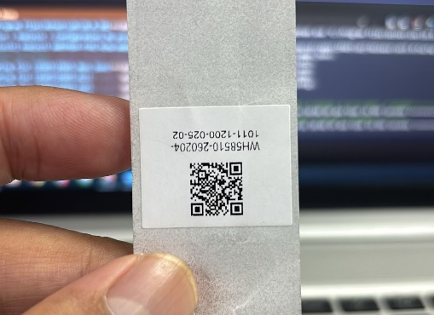

1.10 GitHub Credential
URL | https://github.com
Username | mis@thongguan.com
Password | Mis@Admin78889

1.11 IIS Deployment
Server | 192.168.1.146
Site Name | IPAK5
User name | Administrator
Password | abcd@1234

1.12 MobaXTerm
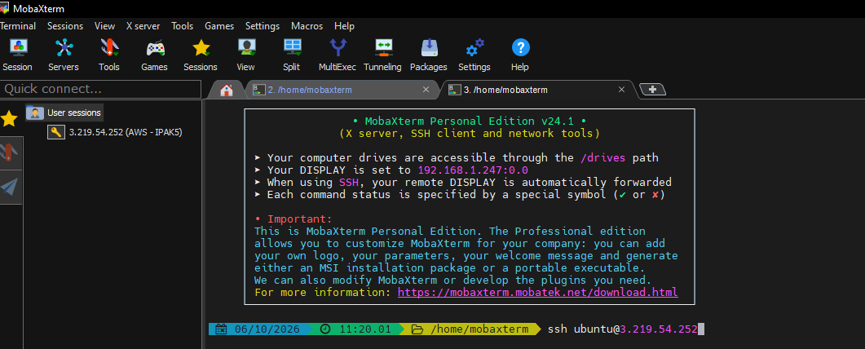

GitHub

GitHub for Each Platform
IPAK5 Code | https://github.com/mistech51/IPAK5.git
IPAK5 RestAPI | https://github.com/mistech51/RestAPI.git
IPAK5 IOS Code | https://github.com/mistech51/IPAK5-IOS-Code.git
IPAK5 Android Code | https://github.com/mistech51/IPAK5-Android-Code.git
IPAK5 Hardware Code | https://github.com/mistech51/IPAK5-Rasp-API.git

Git Clone
[Open Visual Studio 2026]

git clone https://github.com/mistech51/IPAK5.git

Git Push (New Changes)
[Terminal in Visual Studio 2026]

git init
git branch -M main
git add .
git commit -m "Comment"

git remote add origin https://github.com/mistech51/IPAK5.git
git push -u origin main –force
git status

Ubuntu

3.1 Change Password Ubuntu
Last login: Wed Jun 3 02:33:49 2026 from 18.206.107.28
root@ip-172-31-39-226:~#
root@ip-172-31-39-226:~# passwd ubuntu
New password: Ubuntu@2026
Retype new password: Ubuntu@2026
passwd: password updated successfully
root@ip-172-31-39-226:~#

3.2 Add new port and sub domain in AWS
Step 1: Create the folder and add PHP files

# Create the home folder
sudo mkdir -p /var/www/home
sudo chown ubuntu:ubuntu /var/www/home
sudo chmod 755 /var/www/home

# Create a simple PHP file
cd /var/www/home

---------------------------------------------------------------
Step 2: Create systemd service for PHP on port 5002

sudo nano /etc/systemd/system/home.service

[Unit]
Description=PHP Application on Port 5002
After=network.target

[Service]
WorkingDirectory=/var/www/home
ExecStart=/usr/bin/php -S 0.0.0.0:5002
Restart=always
RestartSec=10
User=ubuntu

[Install]
WantedBy=multi-user.target

---------------------------------------------------------------
Step 3: Start the service

# Reload systemd
sudo systemctl daemon-reload

# Enable and start the service
sudo systemctl enable home
sudo systemctl start home

# Check status
sudo systemctl status home

---------------------------------------------------------------
Step 4: Open port 5002 in AWS Security Group
If not already open, add inbound rule for port 5002 (TCP, source 0.0.0.0/0).

---------------------------------------------------------------
Step 5: Test the application

# Test locally
curl http://localhost:5002/
curl http://localhost:5002/index.php
curl http://localhost:5002/home.php

# Test from browser
# http://3.219.54.252:5002/
# http://3.219.54.252:5002/index.php
# http://3.219.54.252:5002/home.php
---------------------------------------------------------------
Step 6: DNS Setup (AWS Route 53)
---------------------------------------------------------------
Step 7: Add security in Ec2 for the new port

3.3 Change path name in /var/www
Step 1: Stop the service

sudo systemctl stop home
sudo systemctl disable home

---------------------------------------------------------------
Step 2: Rename the folder

sudo mv /var/www/home /var/www/aspnet

---------------------------------------------------------------
Step 3 - 4: Rename the service file and update

sudo mv /etc/systemd/system/home.service /etc/systemd/system/aspnet.service
sudo nano /etc/systemd/system/aspnet.service

[Unit]
Description=ASP.NET Application on Port 5002
After=network.target

[Service]
WorkingDirectory=/var/www/aspnet
ExecStart=/usr/bin/dotnet /var/www/aspnet/IPAK5.dll --urls=http://0.0.0.0:5002
Restart=always
RestartSec=10
User=ubuntu
Environment=ASPNETCORE_ENVIRONMENT=Production

[Install]
WantedBy=multi-user.target
---------------------------------------------------------------
Step 5: Update Apache configuration for app.ipak5.com

sudo nano /etc/apache2/sites-available/app.ipak5.com-le-ssl.conf
---------------------------------------------------------------
Step 6: Reload and start the service

sudo systemctl daemon-reload
sudo systemctl enable aspnet
sudo systemctl start aspnet
sudo systemctl status aspnet

---------------------------------------------------------------
Step 7: Verify everything works

# Test the service
curl http://localhost:5002/

# Test via Apache
curl -H "Host: app.ipak5.com" http://localhost/

# Check port
sudo netstat -tlnp | grep 5002

Deploy to AWS

3.1 HomePage
[Open PowerShell]

PS C:\Users\031545> scp -r C:\xampp\htdocs\HomeIpak5\* ubuntu@3.219.54.252:/var/www/home

ubuntu@3.219.54.252's password: ubuntu@2025

-----------------------------------------------------------------------
[Open in EC2 or MobaXterm]

# login
ssh ubuntu@3.219.54.252
Password: ubuntu@2025

# kill process
ps aux | grep php | grep -v grep
sudo kill -9 <PID>
sudo fuser -k 5000/tcp

# Test the app
curl http://3.219.54.252:5000
curl http://localhost:5000

# Start manually (for debugging)
cd /var/www/home
sudo dotnet IPAK5.dll --urls=http://0.0.0.0:5000

# Start as service (production)
sudo cat /etc/systemd/system/ipak5.service
sudo systemctl restart ipak5
sudo systemctl status ipak5
sudo systemctl enable ipak5

# Restart the apache
sudo apachectl restart

# Verify port is listening
sudo netstat -tlnp | grep 5000

# View logs in real-time - debug
sudo journalctl -u ipak5 -f

3.2 RestAPI
[Open PowerShell]

scp -r C:\Users\031545\source\repos\RestAPI\RestAPI\bin\Release\net8.0\publish\* ubuntu@3.219.54.252:/var/www/RestAPI/

password: ubuntu@2025
---------------------------------------------------------------
[Open in EC2 or MobaXterm]

# login
ssh ubuntu@3.219.54.252
Password: ubuntu@2025

# kill process
ps aux | grep RestAPI | grep -v grep
sudo netstat -tlnp | grep 5001
sudo lsof -i :5001
sudo pkill -f "RestAPI.dll"

# Test the app
curl http://localhost:5001/swagger/index.html
curl http://localhost:5001/swagger/ipak5/swagger.json

# Start manually (for debugging)
cd /var/www/RestAPI
sudo nohup dotnet RestAPI.dll --urls=http://0.0.0.0:5001 > /tmp/restapi.log 2>&1 &

# Start as service (production)
sudo cat /etc/systemd/system/restapi.service
sudo systemctl restart restapi
sudo systemctl enable restapi
sudo systemctl status restapi

# Restart the apache
sudo systemctl restart restapi
sudo apachectl restart

# Verify port is listening
sudo netstat -tlnp | grep 5001

# View logs in real-time - debug
sudo journalctl -u restapi -f

3.3 App
[Open PowerShell]

scp -r C:\Users\031545\source\repos\IPAK5\bin\Release\net9.0\publish\* ubuntu@3.219.54.252:/var/www/aspnet/

Password: ubuntu@2025

---------------------------------------------------------------
[Open in EC2 or MobaXterm]

# login
ssh ubuntu@3.219.54.252
Password: ubuntu@2025

# kill process
ps aux | grep IPAK5.dll | grep -v grep
sudo kill -9 [pid]
sudo pkill -f "IPAK5.dll"

# Test the app
curl http://3.219.54.252:5002
curl http://localhost:5002

# Start manually (for debugging)
cd /var/www/aspnet
sudo dotnet IPAK5.dll --urls=http://0.0.0.0:5002

# Start as service (production)
sudo cat /etc/systemd/system/aspnet.service
sudo systemctl restart aspnet
sudo systemctl enable aspnet
sudo systemctl status aspnet

# Restart the apache
sudo systemctl restart aspnet

# Verify port is listening
sudo netstat -tlnp | grep 5002

# View logs in real-time - debug
sudo journalctl -u aspnet -f

3.4 API Hardware
[Open PowerShell – depend on where you save your file]

scp -r C:\Users\031545\Desktop\IPAK5_Project\Raspberrypi_API\job.php ubuntu@3.219.54.252:/var/www/home/api/

Password: ubuntu@2025

---------------------------------------------------------------

[Open in EC2 or MobaXterm]

# login
ssh ubuntu@3.219.54.252
Password: ubuntu@2025

# kill process
ps aux | grep php | grep -v grep
sudo kill -9 <PID>
sudo fuser -k 5000/tcp

# Test the app
curl http://3.219.54.252:5000
curl http://localhost:5000

# Start manually (for debugging)
cd /var/www/home
sudo dotnet IPAK5.dll --urls=http://0.0.0.0:5000

# Start as service (production)
sudo cat /etc/systemd/system/ipak5.service
sudo systemctl restart ipak5
sudo systemctl status ipak5
sudo systemctl enable ipak5

# Restart the apache
sudo apachectl restart

# Verify port is listening
sudo netstat -tlnp | grep 5000

# View logs in real-time - debug
sudo journalctl -u ipak5 -f

Install IIS in Local PC / Windows Server

Install IIS & Windows Features (via GUI)
- Press Win + R, type optionalfeatures, and press Enter.
- Check Internet Information Services.
- Expand Internet Information Services > Web Management Tools and check IIS Management Console. Expand Internet Information Services > World Wide Web Services > Application Development Features and check ASP.NET 4.8 (or ASP.NET 4.5).
- Scroll down to Windows Process Activation Service (WAS) and check it along with its sub-features (ensure Process Model, Configuration APIs, and Net Environment are selected).
- Click OK and restart your computer if prompted

Install ASP.NET Core Hosting Bundle (For ASP.NET Core REST APIs)
- Open PowerShell/Installer and run:
winget install Microsoft.DotNet.AspNetCore.HostingBundle.8 --accept-source-agreements --accept-package-agreements

Enable & Start Web Listener Services (WAS & W3SVC)
- Open PowerShell as Administrator.
- Set service startup types to automatic and start them:
Set-Service -Name WAS -StartupType Automatic; Start-Service WAS;
Set-Service -Name W3SVC -StartupType Automatic; Start-Service W3SVC
- Alternatively, restart/start via Admin terminal using net start WAS, net start W3SVC, and iisreset.

Configure Firewall Rules
- Press Win + R, type wf.msc, and press Enter.
- Click Inbound Rules in the left panel, then click New Rule... in the right panel.
- Select Port > TCP and enter your desired local server ports (e.g., 80, 81, 82, 443, 8080).
- Select Allow the connection, keep profile defaults (Domain, Private, Public), name the rule (e.g., IIS Custom Server Ports), and click Finish.

Create Website Directory & Set Security Permissions
- Open File Explorer, navigate to C:\inetpub\wwwroot\, and create your site/project folder (e.g., MyNewSite or specific project directories like IPAK5).
- Place your web files (such as index.html, default.aspx, or API assets) inside the directory.
- Right-click the folder > Properties > Security tab.
- Click Edit... > Add..., add the IIS_IUSRS and IUSR accounts, and grant them Read & execute and List folder contents permissions.

Configure Sites in IIS Manager
- Press Win + R, type inetmgr, and press Enter.
- Expand your computer name in the left Connections pane, right-click Sites, and select Add Website....
- Enter the Site name and map the Physical path to your created folder.
- Set the Port to an open port (e.g., 80, 81, 82, or 8080) and click OK

Generate & Bind Self-Signed SSL Certificate (Optional - for HTTPS)
- In IIS Manager, select your top-level machine name in the left panel and double-click Server Certificates.
- Click Create Self-Signed Certificate..., enter a friendly name (e.g., LocalDevCert), and click OK.
- Click your website under Sites, click Bindings... > Add....
- Change Type to https, select LocalDevCert from the SSL certificate dropdown, click OK, and close.

Generate & Bind Self-Signed SSL Certificate (Optional - for HTTPS)
- Open your web browser and test access to your endpoints:
- HTTP Access: http://localhost:8080 (or http://localhost:81/index.html)
- HTTPS Access: https://localhost
- API Swagger UI: http://localhost:82/swagger/index.html
- To verify active port listeners via terminal, run: netstat -ano | findstr LISTENING.

Install IPAK5 in Local PC / Windows Server

Create Folder IPAK5 in Local
- C:\inetpub\wwwroot\IPAK5
- Make sure have this folder in above link, that get from MIS Path: \\192.168.1.149\mis$\IPAK5LocalCode

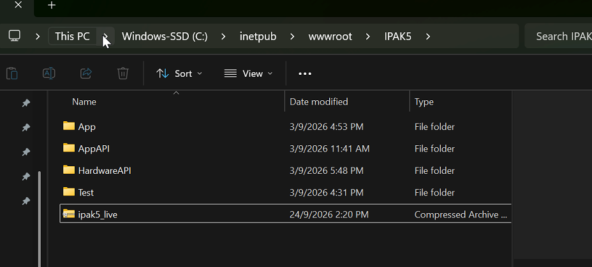

- Open App Folder (PWA web)> Click Edit in appsettings file > Change SITEURL and API ip address > Click Save.
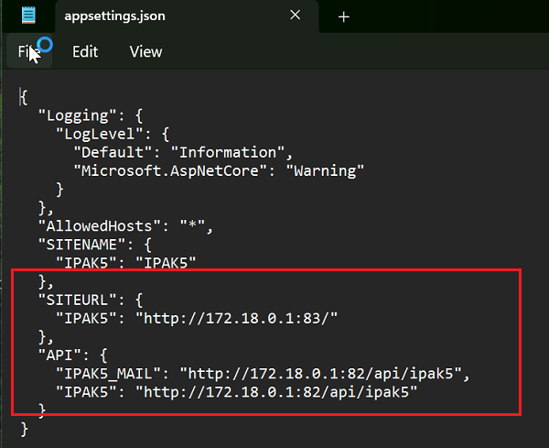
- Open AppAPI Folder (RestAPI PWA Web) > Click Edit in appsettings file > Change SITEURL and API ip address > Click Save.
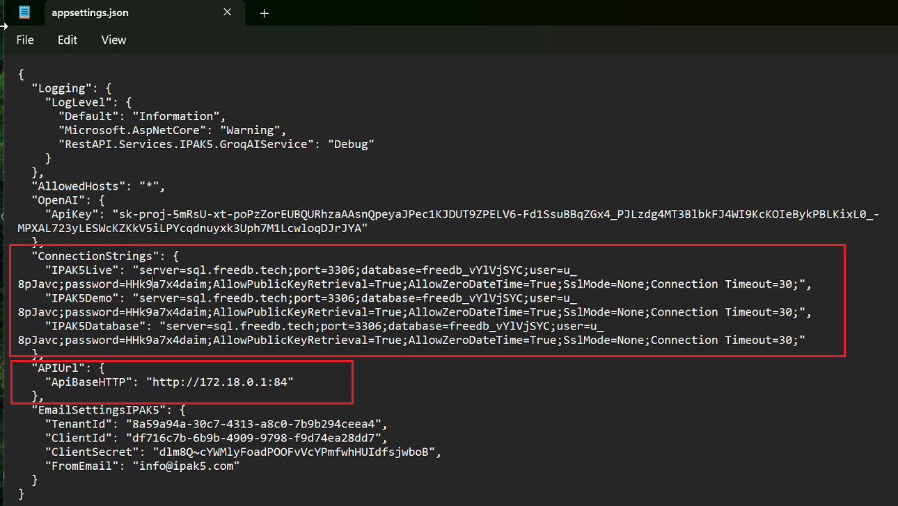

Change URL in Hardware
- Change URL in file: test_api_ipack5.py
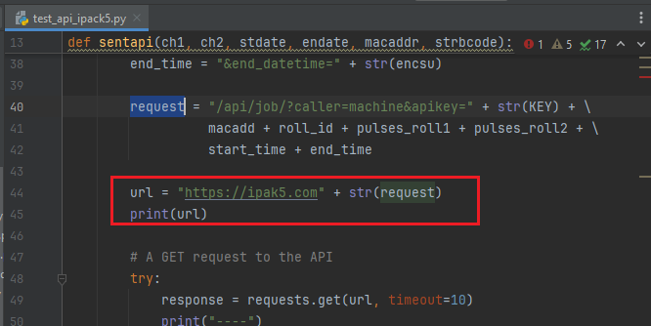

Do this when change code in Hardware

7.1 Command used in Raspberry Pi (if have new changes).
# Remote the Hardware using VNC
Connection IP: (check ip on device screen)
password: ida6422690

# Make it read and write file
sudo chown -R pi:pi /home/pi/PythonProj/iDSWRAP/
sudo chmod -R 775 /home/pi/PythonProj/iDSWRAP

# Open Folder: /home/pi/PythonProj/iDSWRAP
# Right Click the folder > Select Text Editor
# Made Changes > Click Save

# Run this once add new changes depend on file_name.py
sudo pkill -f file_name.py
sudo pkill -f "(main|setting|synchtx|test_api_ipack5)\.py"

# Clean database
cd PythonProj/iDSWRAP
mysql -u ida -p'ida6422690' -e "UPDATE idaesd.ipak5 SET updtms = '1';"

# Check remaining
mysql -u ida -p'ida6422690' -e "SELECT COUNT(*) as total FROM idaesd.ipak5;"

# Update file_name.py with the new version above
nano file_name.py

# Make all critical files owned by root and read-only
cd /home/pi/PythonProj/iDSWRAP/
sudo chown root:root file_name.py
sudo chmod 444 file_name.py

# Make the entire directory read-only for users
sudo chmod 555 /home/pi/PythonProj/iDSWRAP/
sudo reboot`

7.2 Command use for debug local DB in Raspberry Pi.
# Debug database capture data or not
mysql -u ida -p'ida6422690' -e "
USE idaesd;
DELETE t1 FROM ipak5 t1
INNER JOIN ipak5 t2
WHERE t1.stdate = t2.stdate
AND t1.endate = t2.endate
AND t1.pulse1 = t2.pulse1
AND t1.pulse2 = t2.pulse2
AND t1.macaddr = t2.macaddr
AND t1.id > t2.id;
"

# Check remaining
mysql -u ida -p'ida6422690' -e "SELECT COUNT(*) as total FROM idaesd.ipak5;"

# Start main.py
python3 main.py &

# Start synchtx.py (optional)
nohup python3 synchtx.py > sync.log 2>&1 &

# Monitor
tail -f sync.log

Backup and Recover Hardware Code

Install Macrium Reflect
- Using path: \\192.168.1.149\newton$\IPAK5_Backup
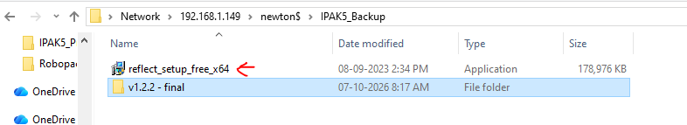

- Double click installer > Click Next > Click Next > Click I accept > Click Next
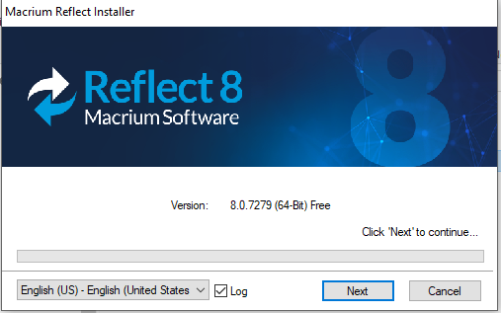
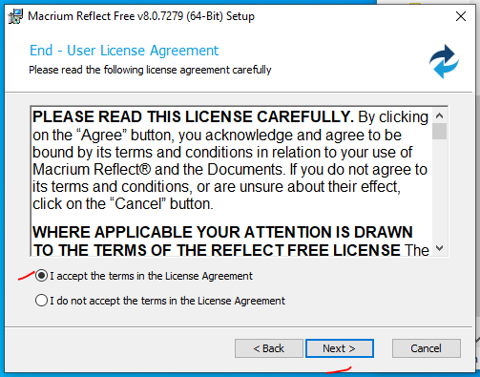
- Click Personal use > Click agree > Click Next
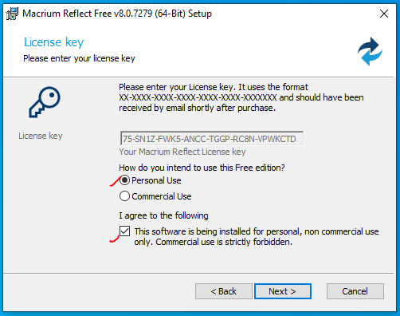
- Untick the register this > Click Next
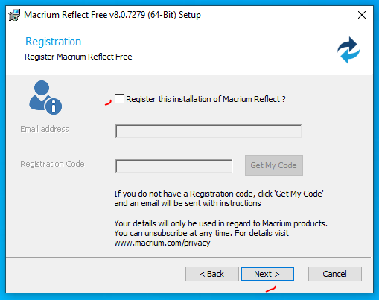
- Untick Install vBoot > Tick Install Desktop Shortcut > Click Next > Click Install and wait until the installation complete
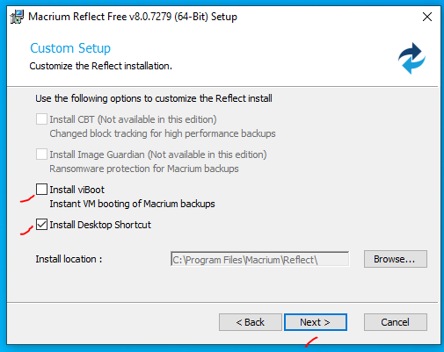
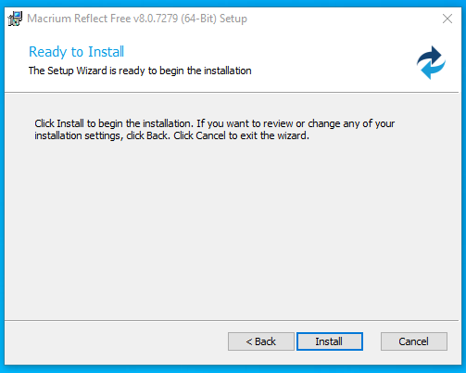
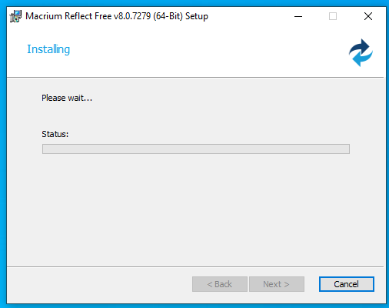
- Click Finish

Copy IPAK5 Hardware Code
- Click Existing Backup > Click Edit
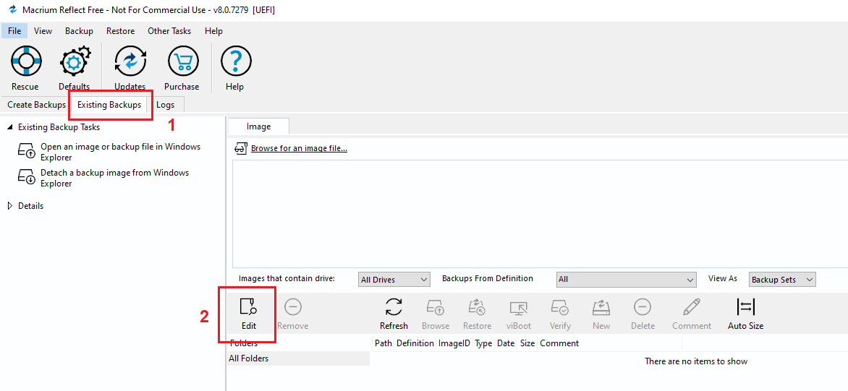
- Insert Backup path: \\192.168.1.149\newton$\IPAK5_Backup\<filename> > Click Add to List > Click OK
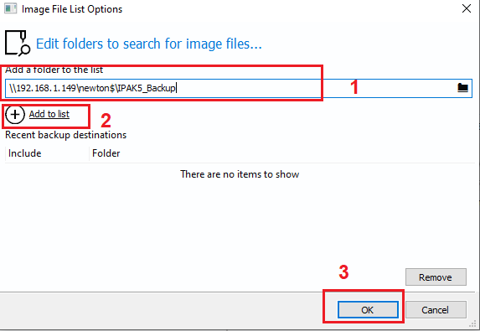
- Select image > Click Restore
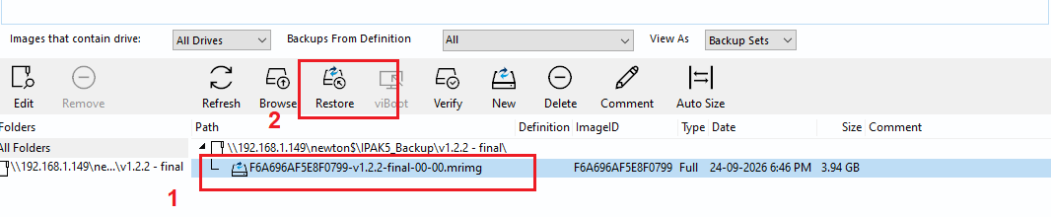

- Click Erase in Destination > Click Copy Partition > Click Next
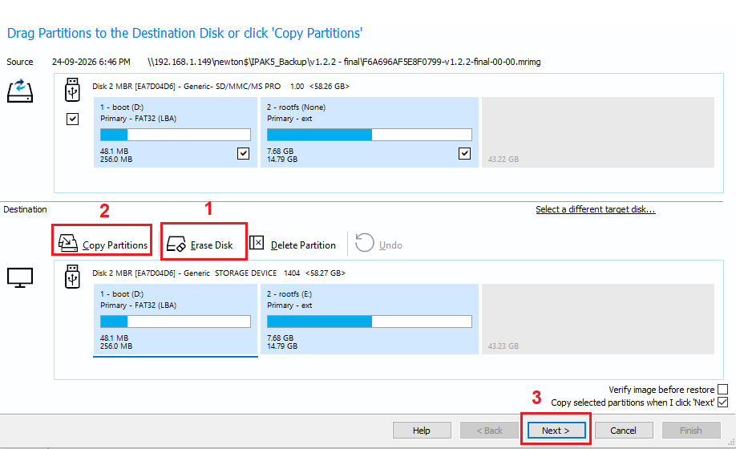

New Backup IPAK5 Hardware Code
- Click Create Backup > Click Image this disk
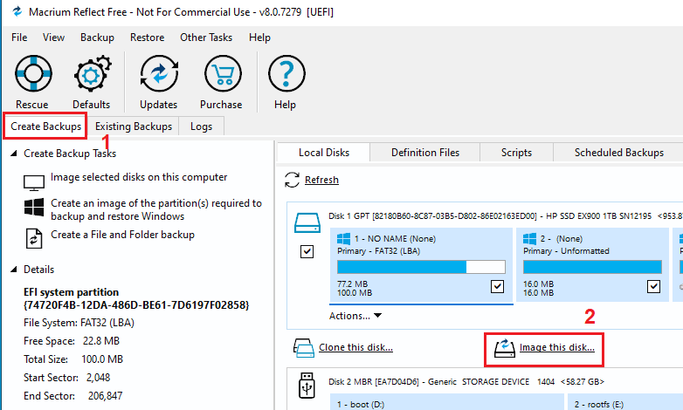
- Insert New File Name or Existing File Name > Click Next
